A device that gives the motor some initiation to start safely is termed as a Starter. While starting a motor, it draws huge current from the line which damages the internal parts of the motor. Four-point starter helps in limiting the starting current such that the motor begins to attain speed slowly and runs smoothly. It is just similar to a three-point starter. The basic difference is, in the four-point starter field weakening speed control is possible by introducing an additional point (N). Depending upon the rating and size of the motor suitable starter will be selected.

**What is a Four-point Starter?**

* It is named as the 4-point starter because this starter has 4 terminals. One is L (line) connected to supply, one is F (field) connected to the field and the other is A (armature) connected to the armature. Apart from these 3 points, there is one more terminal that is neutral (N) linked to the No voltage coil.
* The starter box includes certain parts such as the spring, handle and an electromagnetic coil. The handle moves the soft iron piece attached, made of insulating material. The electromagnetic coil attracts the soft iron piece when it is energized, the spring produces some opposing force to that of an electromagnetic coil.

**What is the Need for using a 4-point Starter?**

The four-point starter reduces the high initial currents that arise while starting the motor in order to protect the equipment.

**Working Principle of a 4-point Starter?**

The four-point starter commissions on the principle of electromagnetic attraction. The electromagnetic coil gets energized when current is passed through it. Next, the flux produced attracts the soft iron piece affixed to the handle based on electromagnetic attraction principle.

**Construction of a 4-point Starter**

* Line L1 is connected directly to an electromagnet through which current passes and one soft iron piece is attached to it has a notch which is of conducting material.
* The handle is attached to a spring, which opposes the force of electromagnet.
* One terminal of an electromagnet (Overload coil) and another terminal from the handle are made available to contact with a notch. But these two are not in contact they are separated by some distance.  
  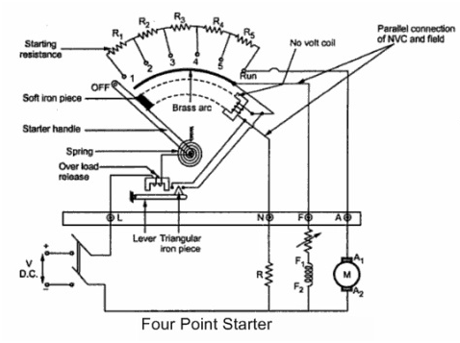
* Another electromagnet (Hold coil) is in series with the starting resistance, and an additional resistance (R) is also linked in parallel to the field winding.
* The handle is used to move on to the studs through resistance which is connected to the armature.
* When the handle is moved current flows such that electromagnet gets energized, which attracts the soft iron piece attached to handle.
* The handle is moved further cutting the resistance (slowly) to its final position such that the motor picks up speed slowly.

**Operation of Four-point Starter**

* When we move the handle it gets in contact with the resistance such that the current starts flowing through the coil.
* Due to the current, the coil gets energized and produces some flux around the coil and also allows current to flow through the field winding.
* While moving the handle further contacting studs through the resistance, the motor picks up speed slowly.
* As speed is increasing we will keep moving the handle till its final position cutting some portion of resistance from the circuit to avoid high initial currents.
* At the final position of the starter (handle), the soft iron piece will be attracted by the magnetic flux of the electromagnetic coil.
* Attraction force by this electromagnetic relay on to the handle will be in the clockwise direction and spring force on the handle will be in an Anti-clockwise direction.
* If attraction force is more compared to spring force then handle will be at the final position, by chance if this spring force is more compared to this electromagnetic force, the handle will come back to its previous position.
* Under normal operating conditions the electromagnetic force is more than spring force such that the handle will be at its final position.

**What Happens if there is a Power Failure while Operating a 4-point Starter?**

* In case if there is a power failure, no current flows and no flux is produced. As there is no flux electromagnetic force will be zero. Only spring force is present so, the handle will come back to its original position.
* The coil helps in opening the starter in case of a power failure, so this coil is called No Volt Coil or No Volt Relay.

**What if an Overload Occurs in a 4 -point Starter?**

* The function of additional resistance in series is to prevent a short circuit in case of overload occurs.
* If overload occurs the armature draws more current than the usual current due to overloading condition. In that case, current drawn by the armature is more and the line current will increase.
* Due to the increase in Line current, magnetic flux will increase. As magnetic flux is more the attraction force on a soft iron piece is able to move the notch up shorting the two contacts.
* The current gets bypassed such that no current and flux is produced in hold Coil (HC). Under overloading conditions handle is moved back to its original position by means of a relay which is called an overload relay.
* Four-point starter functions very well, if there is no voltage(power failure occurs) then starter turns OFF. If the overload current is drawn by the machine then the starter comes back to its original position.

**Applications of Four-point Starter**

* It helps in running Dc shunt motor, limiting the starting current and also in the case of a power failure.
* Prevents excess currents during overload and under load conditions.

**Difference between Three-point and Four-point Starter**

* The basic difference between a 3-point and 4-point starter is their terminals.
* The three-point starter has 3 terminals, (line), F (field) and A (armature).
* The four-point starter has 4 terminals, L (line), F (field), A (armature)and neutral (N).
* Hold coil is in series with the field winding in a 3-point starter. But in four-point starter Hold coil (HC) is in parallel with the field coil.

Thus, in this article, we have discussed in detail about four-point starter construction, operation, working principle, and applications. We have also seen the difference between the 3-point and 4-point starter. Here is a question for the readers, what is a 3-point starter working principle?